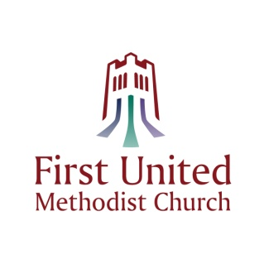
Permanent Fund Request
To: The Allocations/Memorials Committee, First United Methodist Church
A request is hereby made to allocate a portion of the earnings from the Permanent Fund as follows:
Contact Information
Name of Requesting Organization or Individual:
Address:
Street/PO Box: |  |  |  |  |  |  |  | Unit/Apt. #:
City: |  |  |  |  | State: |  |  |  |  | Zip Code:
Email:

Organization Mission:

Annual Budget: | $
Portion Raised: | $
Portion Pledged: | $

Officers and/or Board Members:

References (please include FUMC member name, if applicable):

Amount Requested: | $
(Continued on reverse)
Use additional sheets, as needed

Description of how this allocation will be used:

Please list other sources of income (attach additional sheets as necessary):

Method of payment requested (lump sum or installment):

Discussion of ongoing funding plan, if any:
Date: |  | Signature:

NOTE:
ABSOLUTE DEADLINE FOR REQUESTS IS APRIL 30, 2019.
FOR COMMITTEE USE ONLY

Approved by: |  |  |  | Date:
Disapproved by: |  |  |  | Date:
Comments:

Send email completed form to: | mark.mckeage@gmail.com
Mailing? Send to: | Allocations/Memorials Committee
 | First United Methodist Church of St Petersburg
 | 212 3rd Street North
 | St Petersburg, FL 33701

